Product Catalogue

Connecting Agriculture. Growing Opportunity.
Tashi Global Trading Company Limited
24 products | General varieties & buying guidance
Product descriptions are general buying guidance. Varieties, origin, availability, quality limits, packaging, quantity, price and delivery terms are confirmed in the quotation and contract. AI-generated images are illustrative and do not represent a specific shipment.

Coconut
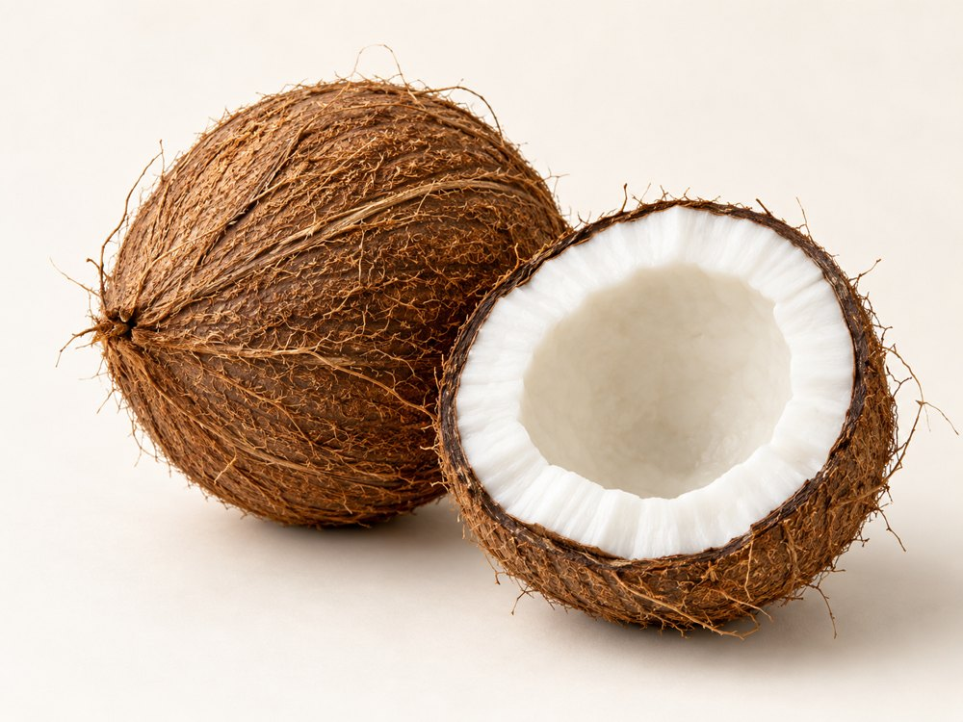
Varieties & forms: Tall types for mature kernels; dwarf types for tender-nut enquiries; named tall–dwarf hybrids.
Buying specifications & uses: Agree maturity, husked form, nut weight and kernel condition. Used for fresh coconut water, culinary kernel and processing.
Handling: Agree maturity, ventilation and temperature for the product and journey. Protect from bruising and confirm the required cold chain.

Guava
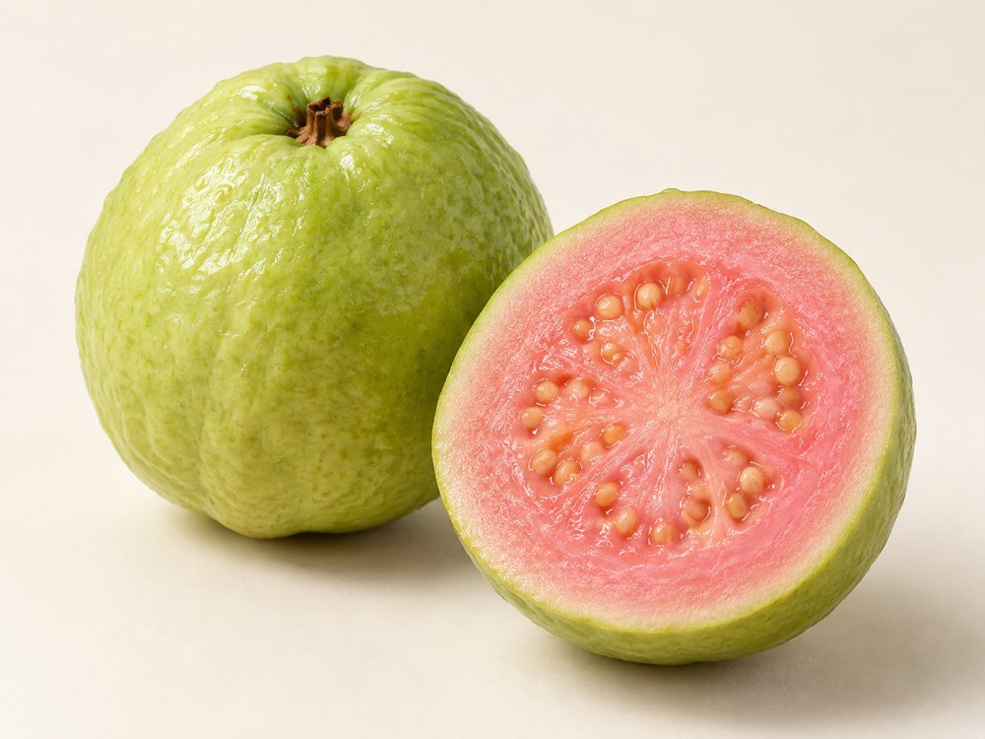
Varieties & forms: White-flesh types; pink or red-flesh types; named cultivars such as Beaumont. Seed content varies.
Buying specifications & uses: Specify flesh colour, firmness, fruit weight and ripeness. Suitable for fresh eating, juice, purée and preserves.
Handling: Agree maturity, ventilation and temperature for the product and journey. Protect from bruising and confirm the required cold chain.

Dragon Fruit
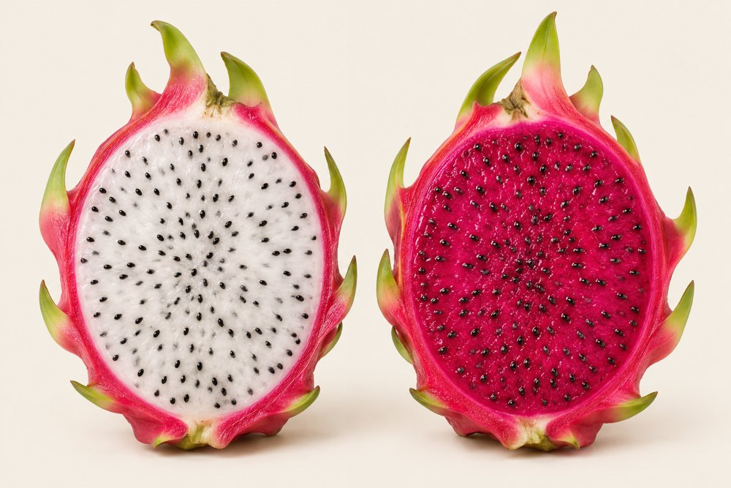
Varieties & forms: Red skin with white flesh; red skin with red or purple flesh; yellow skin with white flesh.
Buying specifications & uses: Agree fruit weight, flesh colour, maturity, sweetness and skin condition. Used fresh, in beverages and desserts.
Handling: Agree maturity, ventilation and temperature for the product and journey. Protect from bruising and confirm the required cold chain.

Lemon & Seedless Lime
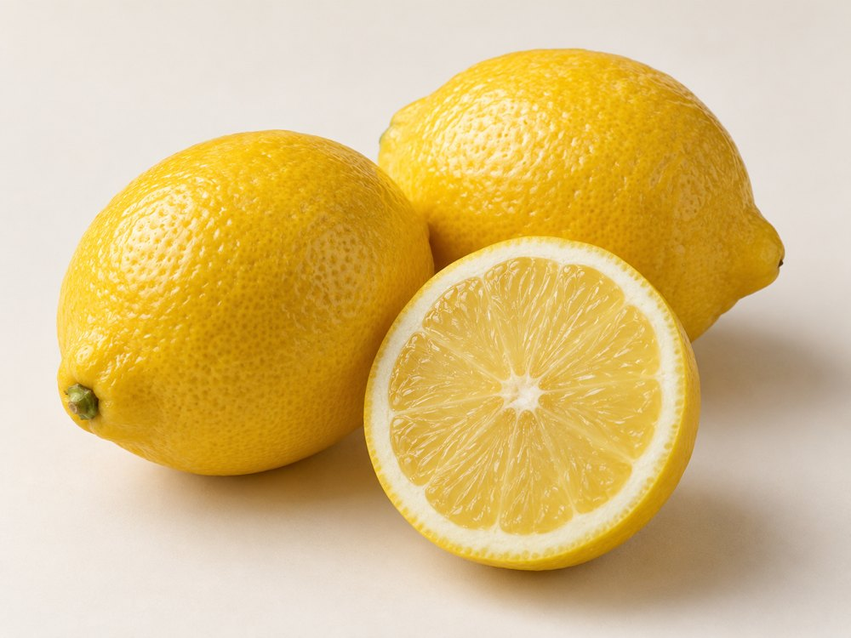
Varieties & forms: Eureka and Lisbon lemons; Meyer citrus hybrid; Persian / Tahiti lime, a separate citrus type that is normally seedless.
Buying specifications & uses: Agree size, skin colour, juice content and seed tolerance. Handling differs between lemons and limes; used in food and beverages.
Handling: Agree maturity, ventilation and temperature for the product and journey. Protect from bruising and confirm the required cold chain.

Bananas
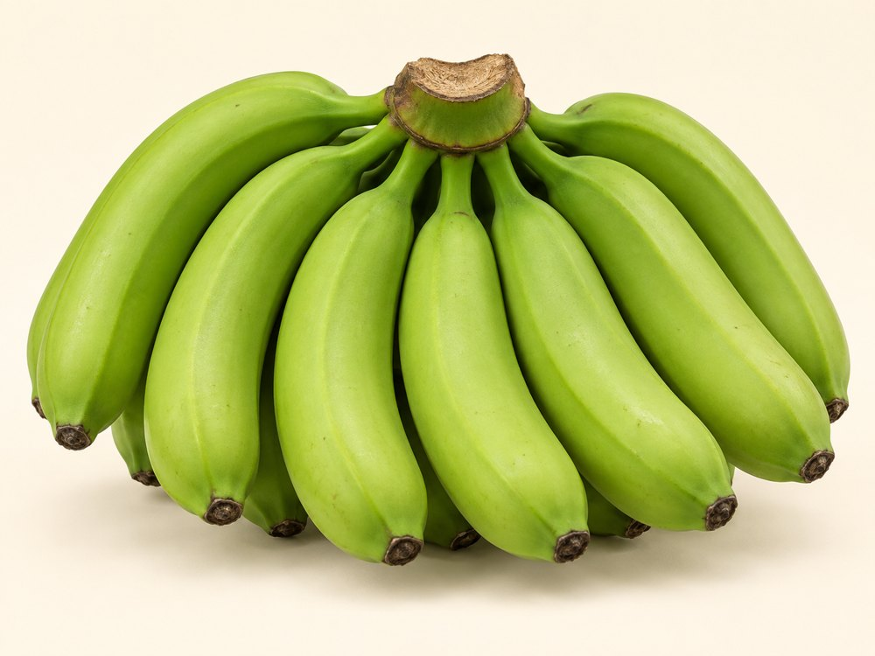
Varieties & forms: Cavendish dessert-banana group; smaller Lady Finger / Pome types; red-skinned bananas. Image: green Cavendish.
Buying specifications & uses: Specify finger size, green or ripened delivery stage, crown condition and carton weight for wholesale or retail.
Handling: Agree maturity, ventilation and temperature for the product and journey. Protect from bruising and confirm the required cold chain.

Podisu Shallot Onion
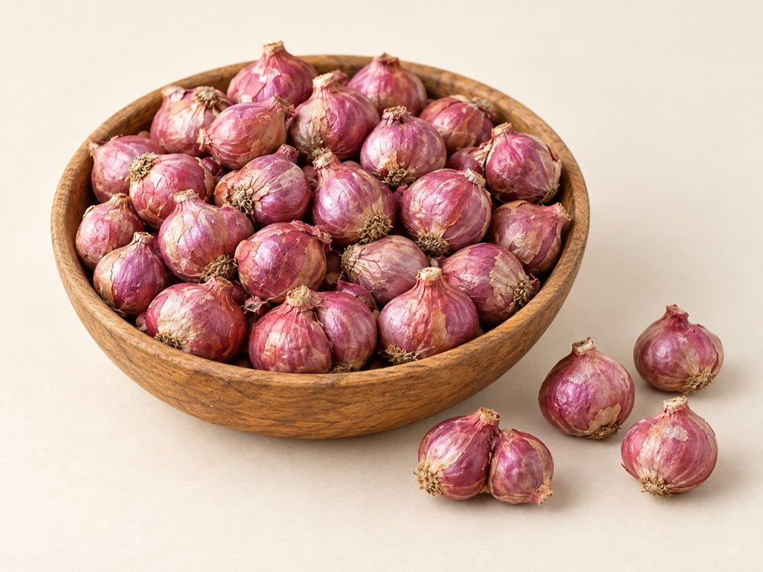
Varieties & forms: Small Indian multiplier shallots, also called sambar onions. Named selections include CO types and MDU 1.
Buying specifications & uses: Agree bulb diameter, cured condition, colour, cluster separation and sprouting limits. Used in curries, sauces and pickles.
Handling: Keep dry and protected from moisture, pests and contamination. Agree ventilation and storage conditions for the supplied form.

Nasik Onion
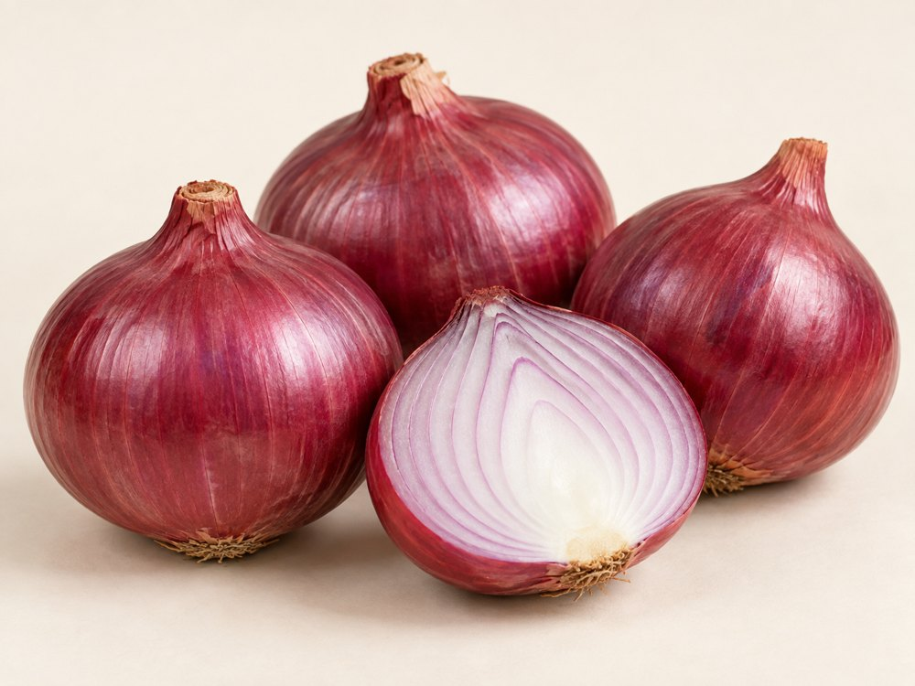
Varieties & forms: Dark-red and light-red selections, graded by size. Nasik / Nashik is a regional trade name; confirm cultivar separately.
Buying specifications & uses: Specify diameter, firmness, dry necks, skin retention and sprouting limits. Suitable for fresh trade and cooking.
Handling: Keep dry and protected from moisture, pests and contamination. Agree ventilation and storage conditions for the supplied form.

Bangalore Rose Onions
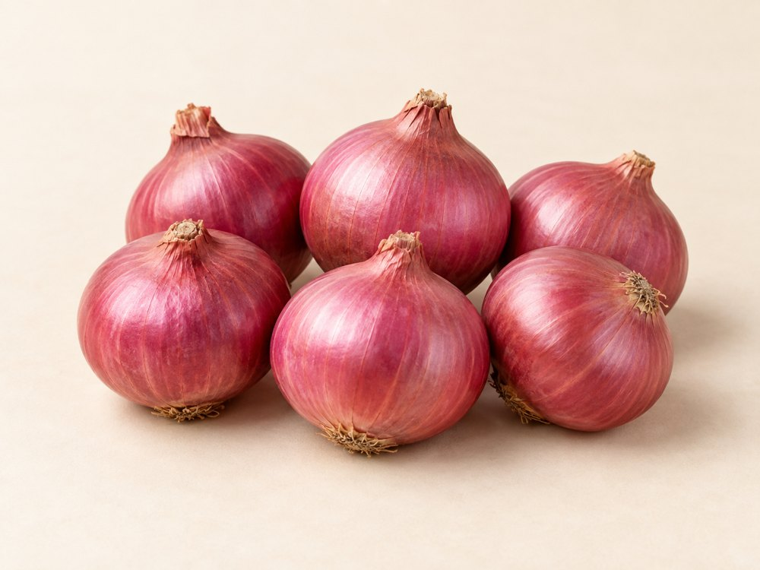
Varieties & forms: A named small rose-onion type. Whole cured bulbs can be selected into smaller and larger grades.
Buying specifications & uses: Confirm type, origin, diameter, firmness and dry skin. Used for cooking, pickling and specialty produce markets.
Handling: Keep dry and protected from moisture, pests and contamination. Agree ventilation and storage conditions for the supplied form.

Bellary Onion
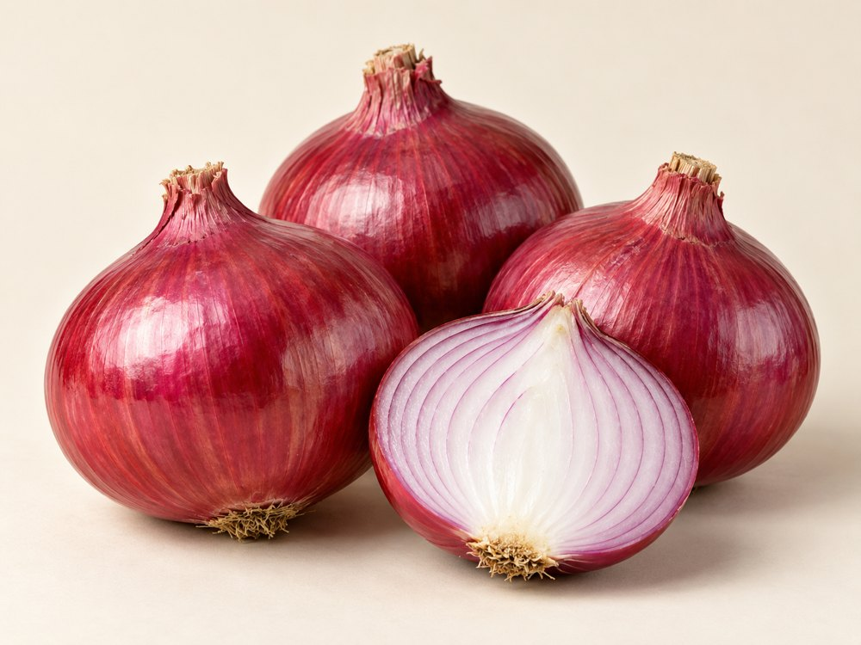
Varieties & forms: Red bulb types in medium and large grades. Bellary is a regional / trade description rather than a complete cultivar specification.
Buying specifications & uses: Agree cultivar, size, colour, curing and damage limits for wholesale, foodservice or processing.
Handling: Keep dry and protected from moisture, pests and contamination. Agree ventilation and storage conditions for the supplied form.

Ginger
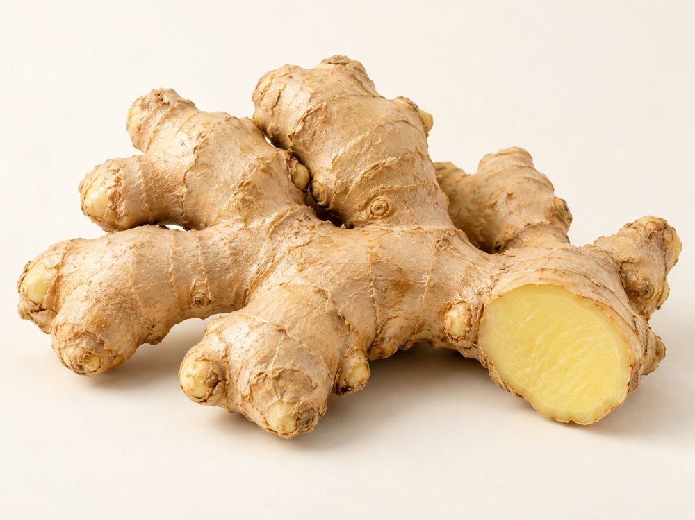
Varieties & forms: Varada: plump fingers. Mahima: extra-bold rhizomes. Rejatha: bold rhizomes. Fresh, dried, sliced or powdered forms.
Buying specifications & uses: Specify form, maturity, finger size, fibre preference and dried-product moisture. Used in cooking, drinks and spice processing.
Handling: Agree maturity, ventilation and temperature for the product and journey. Protect from bruising and confirm the required cold chain.

Garlic
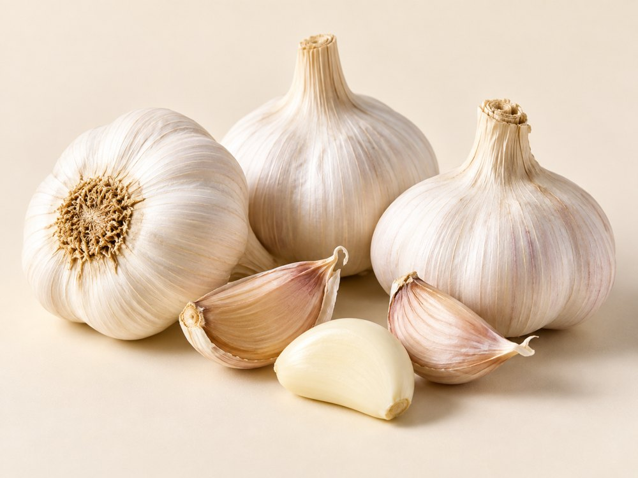
Varieties & forms: White-bulb selections including Yamuna Safed types. Whole cured bulbs, large-bulb grades or peeled cloves.
Buying specifications & uses: Agree diameter, clove uniformity, dryness and sprouting limits. Peeled garlic requires separate storage; used in cooking and seasoning.
Handling: Keep dry and protected from moisture, pests and contamination. Agree ventilation and storage conditions for the supplied form.

Red Dry Chillies
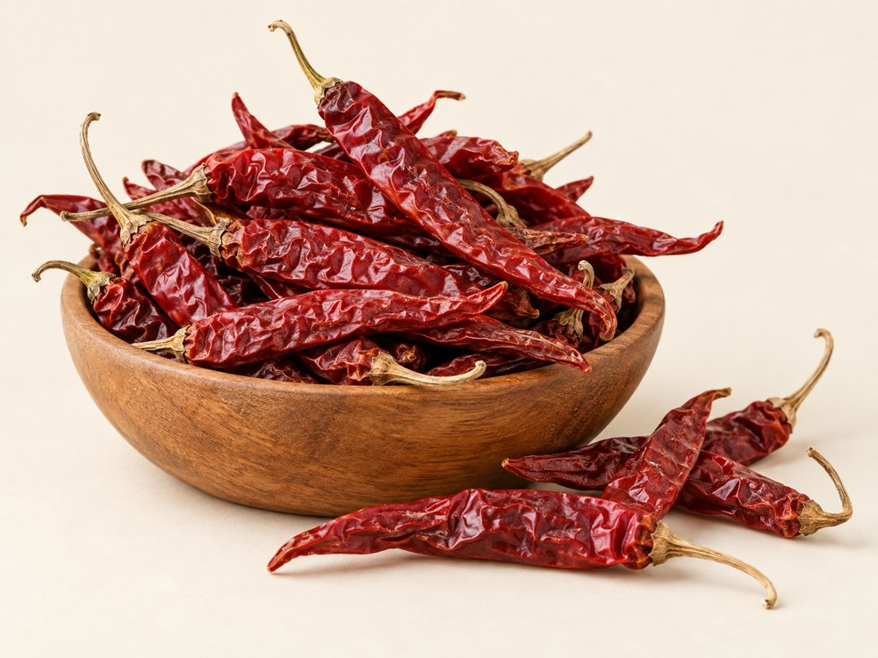
Varieties & forms: Byadagi Kaddi: colour-focused and milder. Guntur Sannam: pungent. Bird’s Eye: small and hot. Heat varies by crop.
Buying specifications & uses: Specify stem-on or stemless, whole or crushed, heat, colour and moisture. Used in sauces, blends and seasonings.
Handling: Keep dry and protected from moisture, pests and contamination. Agree ventilation and storage conditions for the supplied form.

Cumin Seeds
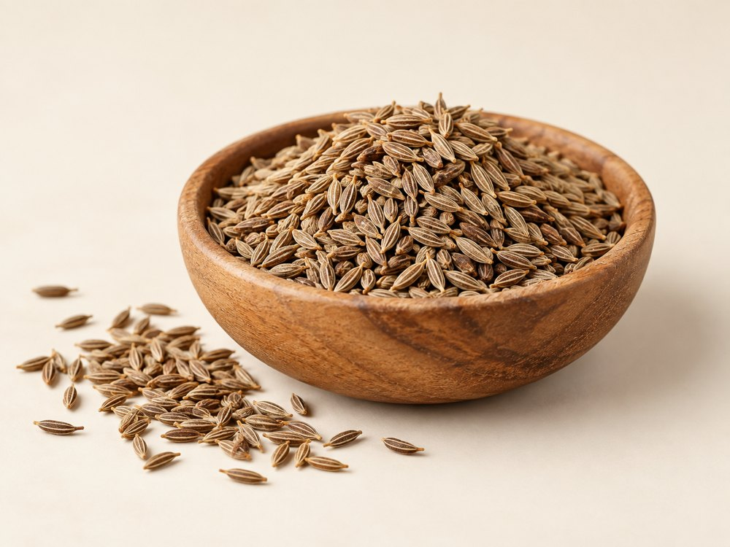
Varieties & forms: Named cultivars include GC 1 and RZ 19. Cleaned and colour-sorted grades describe processing rather than botanical varieties.
Buying specifications & uses: Agree purity, moisture, aroma and foreign matter. Used whole or ground in savoury dishes and spice blends.
Handling: Keep dry and protected from moisture, pests and contamination. Agree ventilation and storage conditions for the supplied form.

Fennel Seeds
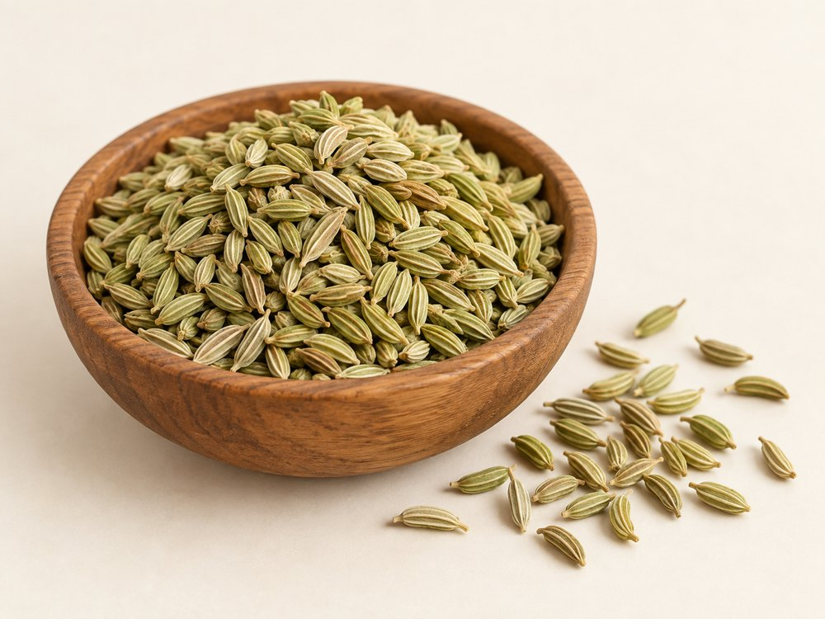
Varieties & forms: CO 1, Gujarat Fennel 1, PF 35 and UF 32 are named selections. Trade grades may focus on bold size or green colour.
Buying specifications & uses: Specify seed size, colour, aroma, purity and moisture for cooking, bakery, confectionery or infusions.
Handling: Keep dry and protected from moisture, pests and contamination. Agree ventilation and storage conditions for the supplied form.

Sesame Seeds
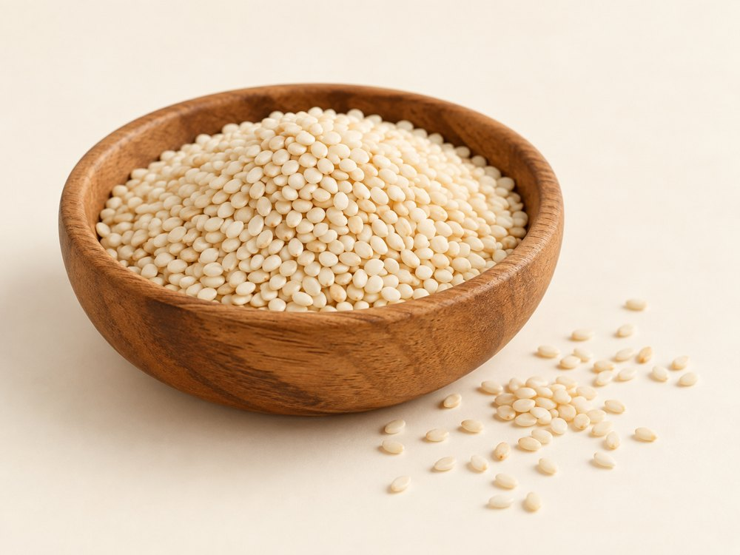
Varieties & forms: Natural white, black or brown seeds; hulled seeds; raw or toasted forms. Hulling is a processing step.
Buying specifications & uses: Agree colour, purity, moisture and residual hulls for bakery, pastes or food use. Sesame is an allergen.
Handling: Keep dry and protected from moisture, pests and contamination. Agree ventilation and storage conditions for the supplied form.

Turmeric Finger
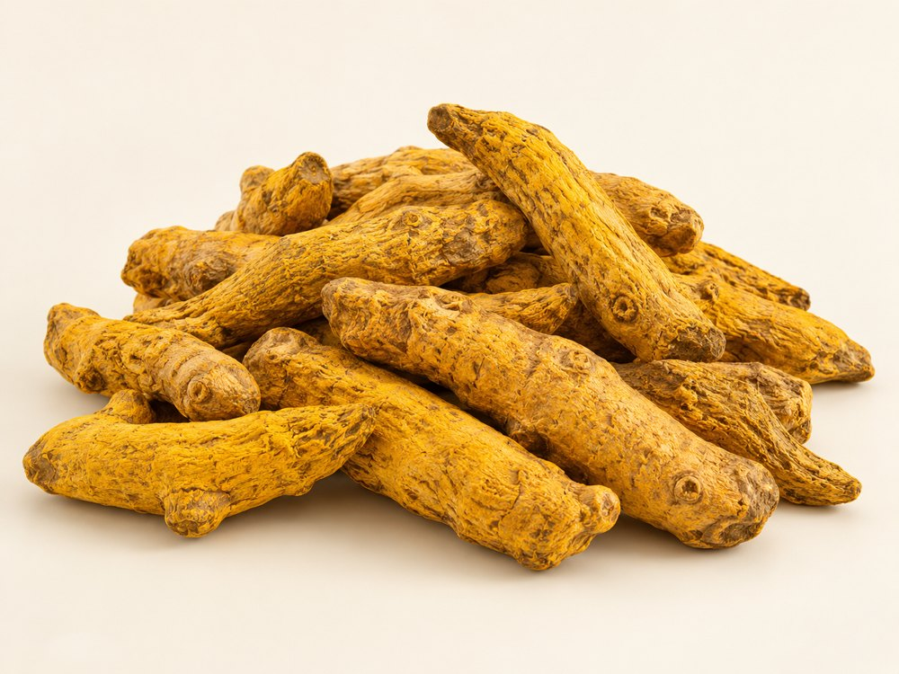
Varieties & forms: Erode local: shorter curved fingers. Salem: larger, longer fingers. Prathibha: a named selection. Polished or unpolished forms.
Buying specifications & uses: Agree colour, moisture, finger size, broken pieces and required curcumin testing. Used for grinding and spice processing.
Handling: Keep dry and protected from moisture, pests and contamination. Agree ventilation and storage conditions for the supplied form.

Tamarind
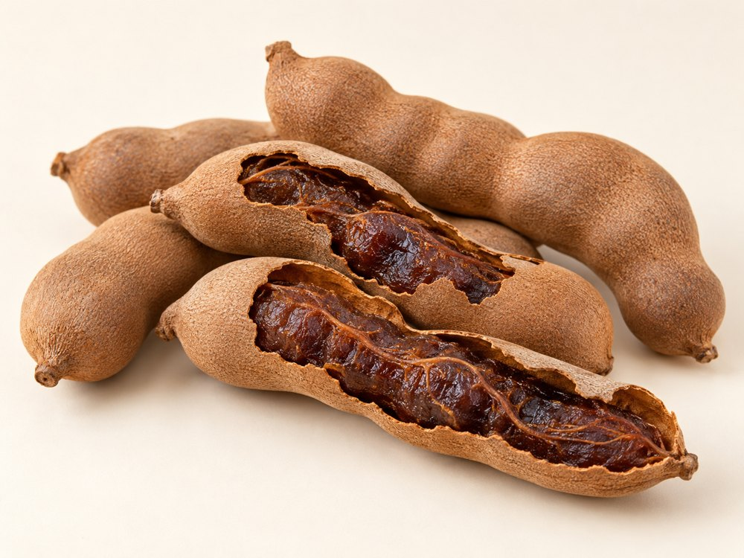
Varieties & forms: Sour types for cooking; sweet types for snacking; whole pods, seeded or seedless pulp and paste.
Buying specifications & uses: Specify sweetness or acidity, seed and fibre content, pulp colour and moisture. Used in sauces, drinks and confectionery.
Handling: Keep dry and protected from moisture, pests and contamination. Agree ventilation and storage conditions for the supplied form.

Groundnut (Peanuts)
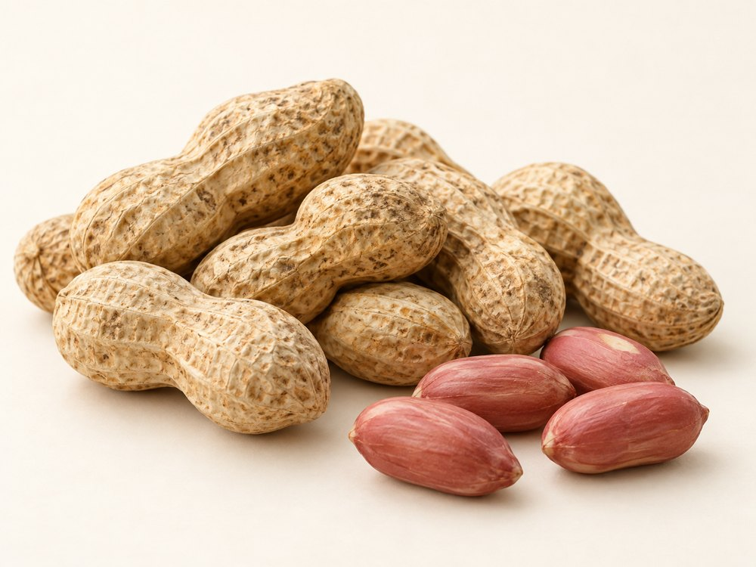
Varieties & forms: Runner: uniform kernels. Virginia: larger kernels. Spanish: smaller reddish-skinned kernels. Valencia: often several kernels per pod.
Buying specifications & uses: Agree in-shell or kernel form, count basis, moisture and food-safety tests. Used for snacks and ingredients. Peanut allergen applies.
Handling: Keep dry and protected from moisture, pests and contamination. Agree ventilation and storage conditions for the supplied form.

Rapeseed Meal
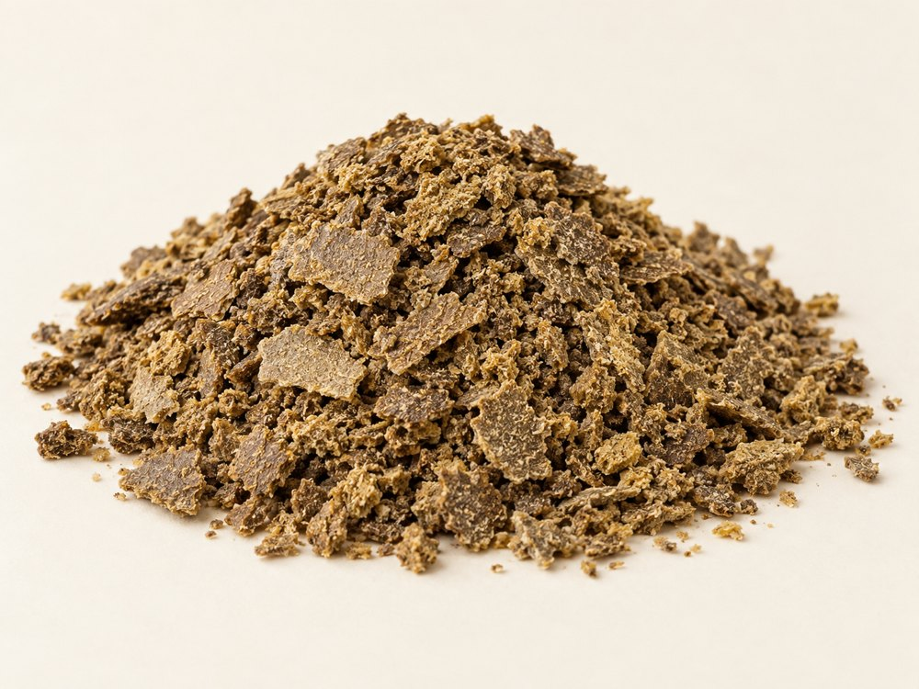
Varieties & forms: Solvent-extracted meal; mechanically pressed expeller cake; canola-quality meal. Composition depends on the process.
Buying specifications & uses: Agree protein, moisture, fibre, residual oil, glucosinolates and analytical basis. A feed ingredient; confirm suitability with the feed formulator.
Handling: Keep dry and protected from moisture, pests and contamination. Agree ventilation and storage conditions for the supplied form.

Blanched Peanuts
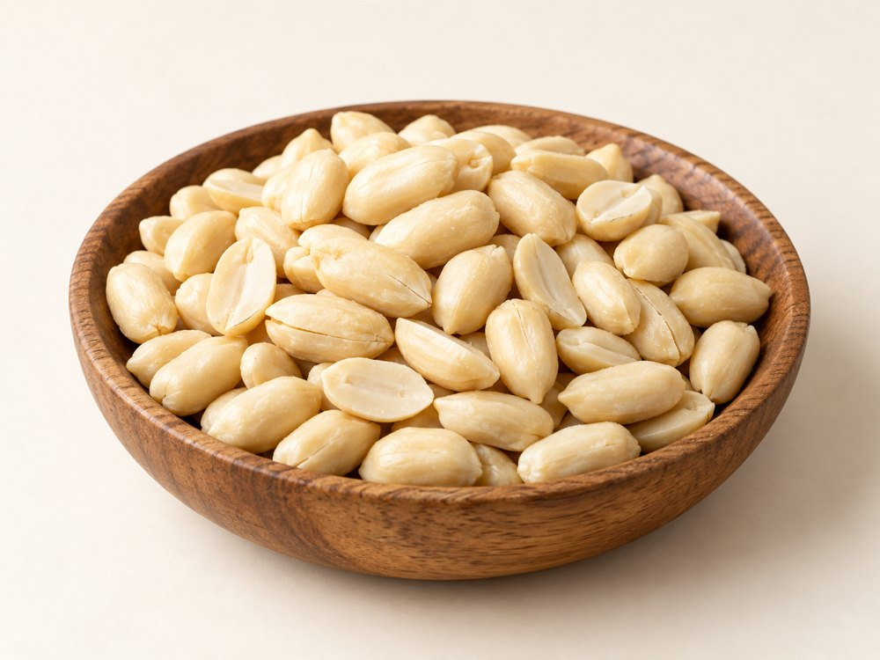
Varieties & forms: Whole kernels, split kernels and sized pieces. Blanching removes skins; confirm the original peanut type separately.
Buying specifications & uses: Specify size, residual skin, raw or roasted status and testing. Blanching alone does not mean ready-to-eat. Peanuts are an allergen.
Handling: Keep dry and protected from moisture, pests and contamination. Agree ventilation and storage conditions for the supplied form.

Chickpeas (Kabuli & Desi)
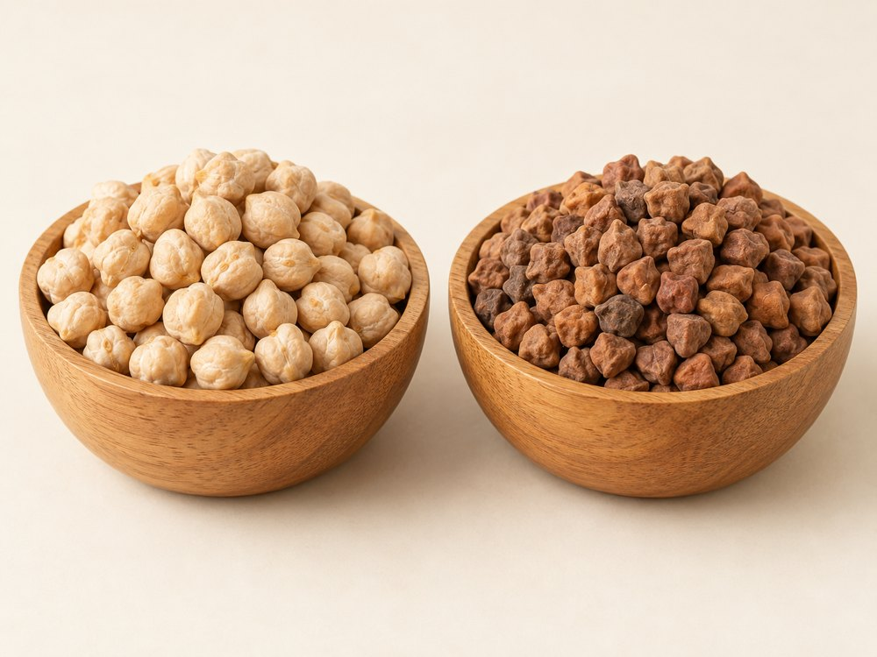
Varieties & forms: Kabuli: larger, lighter seeds. Desi: smaller, darker, more angular seeds. Split, dehulled Desi is a processed form.
Buying specifications & uses: Agree grain size, colour, moisture, purity and damage limits. Used for curries, hummus, flour and pulse processing.
Handling: Keep dry and protected from moisture, pests and contamination. Agree ventilation and storage conditions for the supplied form.

Green Moong Beans
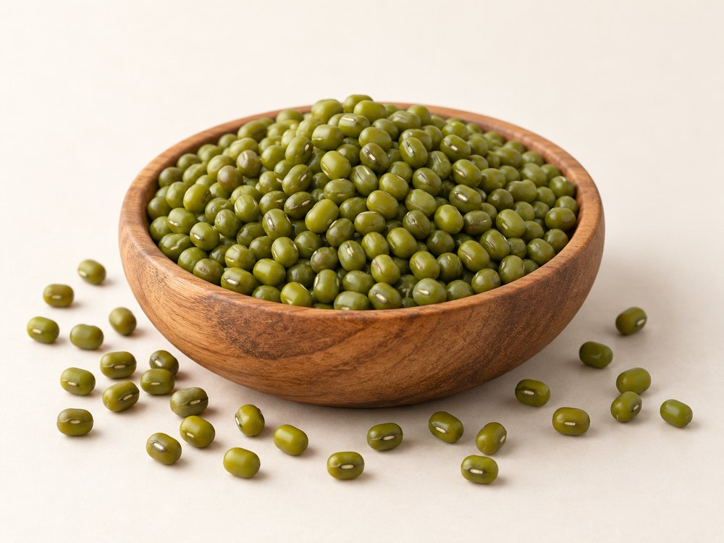
Varieties & forms: Named cultivars include Jade-AU and Crystal. Whole green beans, split skin-on beans and dehulled yellow beans.
Buying specifications & uses: Specify size, moisture, purity and damage. Sprouting needs separate germination and food-safety checks; also used in cooked dishes and flour.
Handling: Keep dry and protected from moisture, pests and contamination. Agree ventilation and storage conditions for the supplied form.

Maize (Corn)
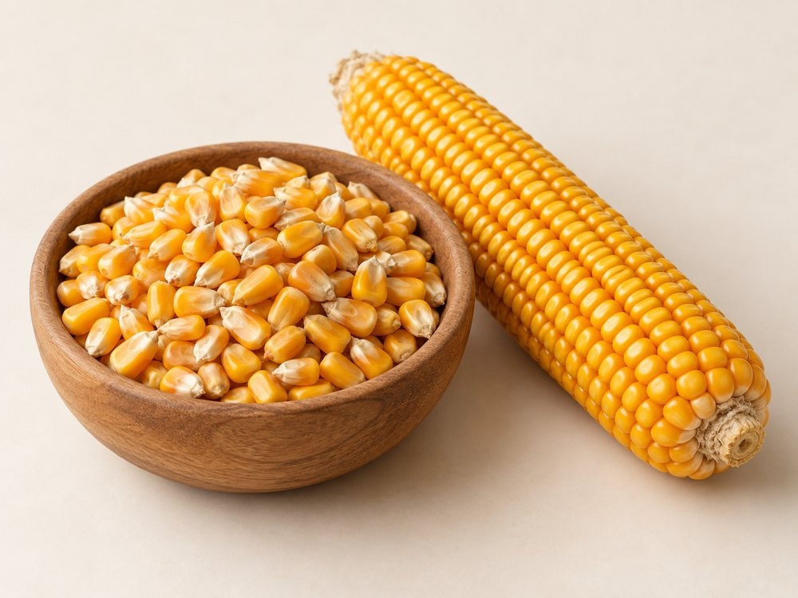
Varieties & forms: Dent: field corn. Flint: harder kernels. Popcorn: selected for expansion. Sweet corn: fresh or processed vegetable.
Buying specifications & uses: For dry grain, agree moisture, colour, test weight and impurities. Food, feed and industrial grades differ; sweet corn needs separate handling.
Handling: Keep dry and protected from moisture, pests and contamination. Agree ventilation and storage conditions for the supplied form.

Chia Seeds
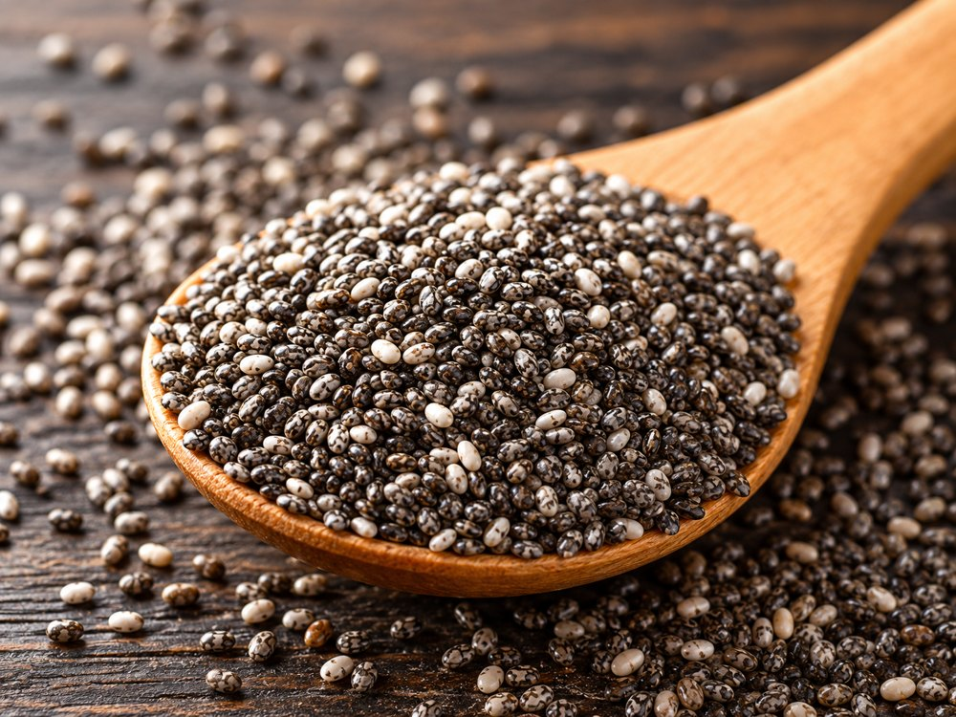
Varieties & forms: Black chia: mixed dark mottled seeds. White chia: selected light seeds. Whole and milled forms are distinct.
Buying specifications & uses: Agree colour, purity, moisture and cleaning. Milled chia also needs a particle-size specification. Used in bakery, cereals and beverages.
Handling: Keep dry and protected from moisture, pests and contamination. Agree ventilation and storage conditions for the supplied form.

Enquiries & ordering
Tashi Global Trading Company Limited
Vietnam
tashiservices@gmail.com
+84 853 891 092
tashiglobal.com
WeChat: wxid_7odlj2723fzd12
WhatsApp and Zalo available on our website.
Product descriptions are general buying guidance. Varieties, origin, availability, quality limits, packaging, quantity, price and delivery terms are confirmed in the quotation and contract. AI-generated images are illustrative and do not represent a specific shipment.
For a quotation, send the product, variety or form, destination, quantity, packaging and preferred shipment period.
Scan for the digital product catalogue:

https://tashiglobal.com/catalogue/

